
2025 Annual Conference
15th – 17th May 2025, Bratislava, Slovakia

Open TMJ surgery in internal derangement and condylar trauma, is it really beneficial?

This will be an Open Meeting

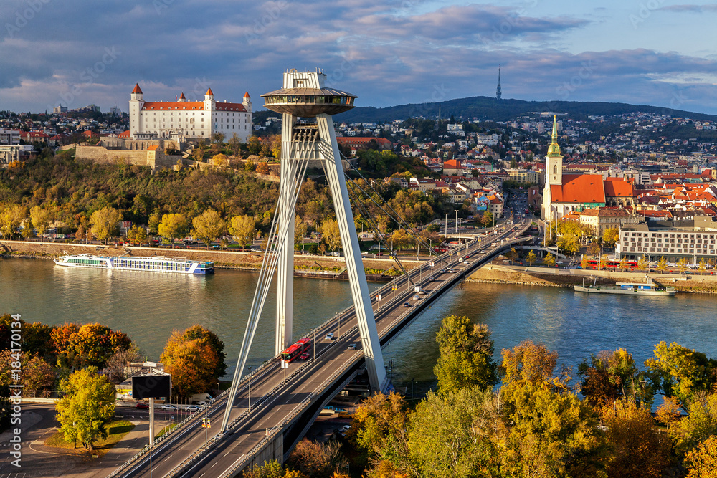

ESTMJS www.estmjs.org

15th – 17th May 2025, Open Meeting
Bratislava, Slovakia

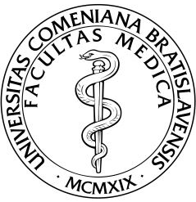
Venue:
University of Bratislava

Meeting Room:
Moskovská 2, Lekárska Fakulta UK, Bratislava

Faculty: Joel Ferri (F)
Andreas Kolk (D)
Vladimir Machoň (CZ)
Andreas Neff D)
Dorrit Nitzan (IL)
Nadeem Saeed (UK)
Bernie Speculand (UK)
Fred Spijkervet (NL)
Dušan Hirjak (SK) (president ESTMJS)

Deadline for Abstract submision: 31st January 2025

15th – 17th May 2025, Open Meeting
Bratislava, Slovakia
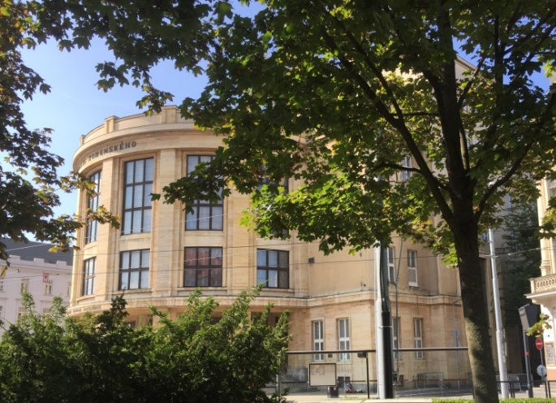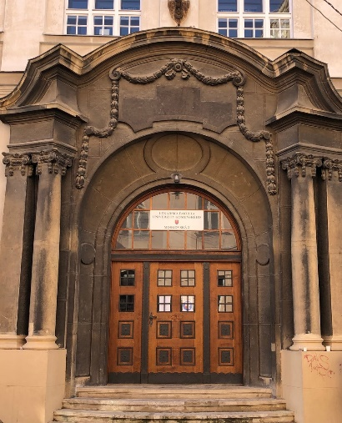

Recommended Accommodation:
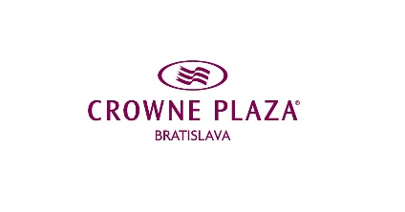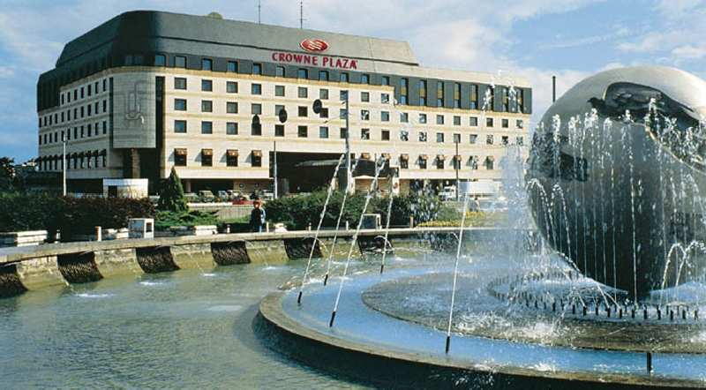

Accommodation: Crowne Plaza, Hodžovo námestie 2, 816 25 Bratislava
To take advantage of the special ESTMJS accommodation rate, please contact legenyova@cpbratislava.sk (password: ESTMJS)

Connections: Airports: Bratislava (SK) or International Vienna Airport (A)
65 km to Bratislava by Bus or Taxi

